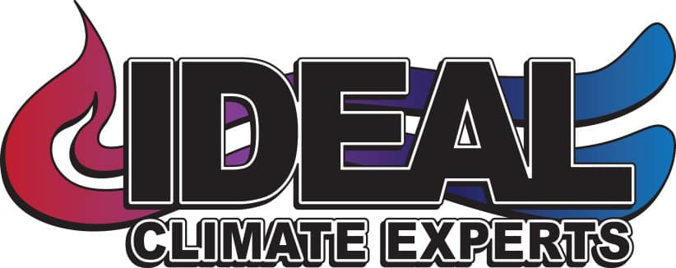

Preventive Maintenance | STANDARD | OPTIMUM | PREMIUM
24 Point Inspection (2 Visits Per Year) | X | X | X
Reminder Service | X | X | X
Repair Warranty | 1yr | 2yr | 3yr
Priority Status | X | X | X
No Overtime/Weekend Charge | - | X | X
Pre-Season Scheduling | X | X | X
Quality Cleaning (AS NEEDED):  Belt Replacement/ Wheel cleaning  Blower Cage  Coil Cleaning  Condenser  Condensate Drain Line Treatment | -  Will Receive Discount Rate for Cleaning Service | X | X
Cost Per Year (One Unit)  *Additional Per System Cost (Yearly) | $140.00  $50.00 | $188.00  $50.00 | $388.00  $110.00

